CHARACTERISTICS:

• Made of non-woven SPP fabric
• Multiple colours option from white, blue, green, red, yellow to orange.
• Nature Rubber Latex Free
• Single elastic
• Comply with European Commission Directive 1935/2004/EC, Regulation (EU) No.10/2011, Regulation (EU) No.2016/1416 and Regulation (EU) 2017/752.

PHYSICAL PROPERTIES

Item |  | Test method | Standard
Weight(g/m2) |  | ISO3801 | 10±1
Break Tensile Properties  (N/5cm) | MD | ISO13934-1 | >15
Break Tensile Properties  (N/5cm) | CD | ISO13934-1 | >8
Elongation Rate(%) | MD | ISO13934-1 | >30
Elongation Rate(%) | CD | ISO13934-1 | >30

PRODUCTS AND DIMENSION SPECIFICATION

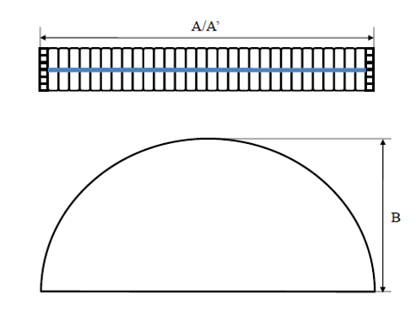
Unit: CM
ECN |  | 113-8850 | 113-8851 | 113-8852 | 113-8853 | 113-8854 | 113-8855 | Tolerance
Colour |  | White | Blue | Green | Red | Yellow | Orange | Tolerance
Dimension | A | 21.5 | 21.5 | 21.5 | 21.5 | 21.5 | 21.5 | ±2
Dimension | A’ | 53 | 53 | 53 | 53 | 53 | 53 | ±1
Dimension | B | 21.5 | 21.5 | 21.5 | 21.5 | 21.5 | 21.5 | ±1
ECN |  | 113-8856 | 113-8857 | 113-8858 | 113-8859 | 113-8860 | 113-8861 | Tolerance
Colour |  | White | Blue | Green | Red | Yellow | Orange | Tolerance
Dimension | A | 23 | 23 | 23 | 23 | 23 | 23 | ±2
Dimension | A’ | 58 | 58 | 58 | 58 | 58 | 58 | ±1
Dimension | B | 21.5 | 21.5 | 21.5 | 21.5 | 21.5 | 21.5 | ±1
Remark: A: Relax, A’: Stretch

Packaging and Storage Specifications

Package/Quantity | 100pcs/bag, 10bags/case
Best Storage Conditions | Temp : 0- 50°C,
 | Humidity 45-85%
 | without sunshine exposure
Country of Origin | China
QUALITY ASSURANCE CRITERIA:

1. Dimension and Function - Critical (AQL1.5, S-2)
• Product dimension out of spec.
• Fabric characteristics out of spec
• Sonic welding strength less than 15N/5cm

2. Visual Inspection/ Attributes - Major (AQL 2.5, L-II)
• Foreign Material
• Dirt
• Thread ends loose or too long(over 1cm)
• Holes/Tears
• Foul odor
• Discolor
• Wrong collar tag
• Wrong stitch
• Cloth surface applied wrongly
• Less than 3 stitches per centimeter

3. Visual Inspection/Attributes - Minor (AQL 4.0, L-II)
• Sewing sundries
• Elastic band end exposed
• Sewing end falling-off
• Jumping Stitch
• Missing stitch
• Unwanted folds
• Elastic tightness non-consistent

Date of Issue: Mar 8, 2022

