Hybridization Oven

Model 5420

VWR Catalog Number 97005-252

VWR Catalog Number 97005-254

Operating Instructions

N2400262 Rev. 2 03-08
Table of Contents
Page
1. Safety 3,4
2. Product Information 4
3. Assembly 4
3.1 Unpacking 4
3.2 Installation 4
4. Operation 5
4.1 Controls and Displays (see figure 1). 5
4.2 Changing the Set Temperature 6
4.3 Setting the Motor Speed 6
4.4 Using the Timer 6,7
4.5 Using the High Temperature Alarm 7
4.6 Loading Carousel 7
4.7 Spindle Adjustment 7
4.8 Removing/Installing Carousel 7,8
4.9 Drip Tray 8
4.10 Reducing the risk of a Hybridization Bottle leak 8
4.10.1 Glass Hybridization Bottles 8
4.10.2 50ml Conical Centrifuge Tubes 8
5. Accessories 8,9
6. Fault Diagnosis 9
7. Technical Specifications 10
8. Door Reversal 11
9. Maintenance and Service 11
9.1 Calibration….……..………………………………………….…….……...11,12
9.2 Cleaning 112
9.3 Replacement of Fuses 12
10. Warranty 13
11. Service 13

1. Safety

The following symbols marked on the equipment mean:

Caution: Read these operating instructions fully before use and pay particular attention to sections containing this symbol.

Attention: Suivre attentivement les instructions avant l’usage et prêtez une attention particulière aux sections comportant ce symbole.

Caution: Surfaces can become hot during use.

Attention: Les surfaces peuvent devenir brûlantes pendant l’usage.

Always observe the following safety precautions:
- Use only as specified by the operating instructions or the intrinsic protection may be impaired. After transport or storage in humid conditions, dry out the unit before connecting it to the supply voltage. During drying out the intrinsic protection may be impaired.
- RISK OF TRAPPING: Do not attempt to add or remove tubes from the Carousel or adjust the clips until the motor has stopped.
- Connect only to a power supply with a voltage corresponding to that on the serial number label.
- Connect only to a power supply that provides a safety ground terminal.
- Before moving, disconnect at the power supply socket. Do not remove the plug from the rear of the unit.
- Do not check the temperature by touch, but instead use the temperature display or a thermometer.
- To reduce the risk of eye injury during high temperature operation, use safety goggles or spectacles.
- Do not touch surfaces that become hot during high temperature operation.
- Ensure that the operating temperature is less than the maximum operating temperature of your sample material.
- Ensure that the power switch is easily accessible during use.
- Do not block or restrict ventilation slots.
- If liquid is spilled inside the unit, disconnect it from the power supply and have it checked by a competent person.
- It is the user’s responsibility to carry out appropriate decontamination if hazardous material is spilled on or inside the equipment.
- This product must be used with an UL / CSA Certified power supply cord set rated for a minimum temperature of 90˚C.
- The Power Cord supplied with the unit is the disconnect means.
- Do not position the unit so that it is difficult to operate the disconnecting means.
- Before using any cleaning or decontamination method except those recommended by the manufacturer, users should check with the manufacturer that the proposed method will not damage the equipment.

Product Information
The Hybridization Oven is a high capacity hybridization oven that can be utilized for all your Southern, Northern and Western blotting needs. It will hold up to ten standard 35mm diameter by 300mm long bottles or twenty 150mm long bottles. Bottles are available in four lengths – 100, 150, 225 or 300mm. The Hybridization Oven can also be adapted for use with 1.5/2.0mL, 15mL and 50mL conical centrifuge tubes (with an optional Carousel) or as a Platform Rocker to hold Tupperware® type containers or heat sealed bags (with an optional platform attachment).
The Hybridization Oven utilizes an adjustable speed Carousel and slight offset on its two Spindles to provide the three-dimensional motion needed for excellent membrane coverage. Forced air circulation coupled with microprocessor controlled temperature control combine to provide unsurpassed temperature performance and the most consistent conditions from procedure to procedure. Please note that the convection fan operates continuously whenever the unit is turned on.

3. Assembly

3.1 Unpacking
- Remove packing materials carefully, and retain for future shipment or storage of the unit.
- Inspect for damage. Report all shipping damage to the carrier immediately. Shipping damage is covered by the carrier and repair/replacement for shipping damages must be coordinated through the carrier.
- Complete and return the Warranty Registration Card.
- Package should contain:
(1) Hybridization Oven
(1) Power line cord
(1) Operating instructions
*(2) 35mm diameter X 300mm long glass hybridization bottles
*(2) Spare “O” rings
(1) Hex Key
(1) Stainless Steel Drip Tray
* = not included with Models 230402TW & 230402TW12

3.2 Installation
- Place the Hybridization Oven on a flat and stable surface, preferably away from drafts.
- Fit the power line cord into the IEC power socket on the rear of the unit.

4. Operation

4.1 Controls and Displays (see figure 1).
The Power Switch: controls power to the unit and is located on the rear of the oven nearest the power cord.
The Carousel Switch: stops rotation of Carousel for loading and unloading of tubes.
The Display shows the chamber temperature in ˚C during normal operation. It displays the set temperature when the set button “F” is pressed.
Function switch “F” – Pressing the “F” button enters the “Function Select Mode”
Set Switch “S” – Pressing the “S” buttons enters the “Set Mode” to set temperatures or accept menu changes.
Increment / Decrement Dial: Turning the dial counter clockwise will decrease the display setting and turning the dial clockwise will increase the display setting.
Carousel Indicator: The indicator will illuminate GREEN when the carousel is turning.
Heat Indicator: The indicator will illuminate RED when the heating element is powered on and heating the chamber.

Figure 1

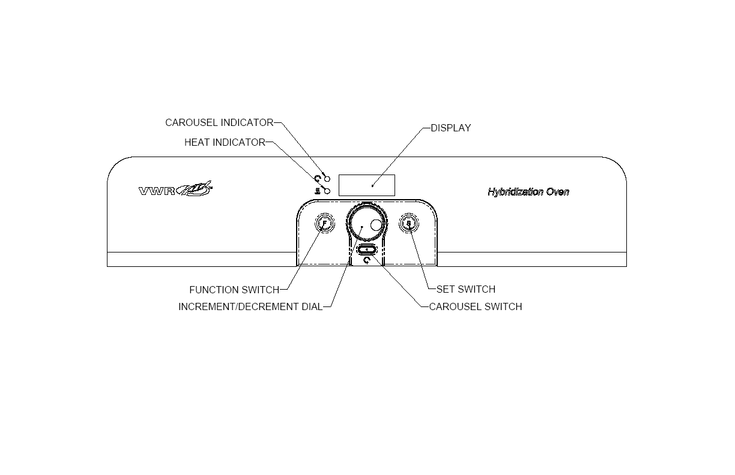

4.2 Changing the Set Temperature

- Press the “F” button once until TSEt is indicated on the display. The display will alternate between TSEt and the set temperature value.
- Press the “S” button to enter the “Set Temperature” mode.
- Adjust the Increment / Decrement Dial until the desired new Set Temperature is indicated on the display.
- Press the “S” button to accept and store the new value in memory.

4.3 Setting the Motor Speed
To enter a new motor speed”
- Press the “F” button until SPd is indicated on the display. The display will alternate between SPd and the current motor speed value.
- Press the “S” button to enter the “Motor Speed” mode.
- Use the Increment / Decrement Dial to obtain the required motor speed. The display flashes when in the “Set Motor Speed” mode.
- When the desired motor speed is indicated, press “S” again. This value is then stored in memory and the unit will retain this value after unit is switched off.

4.4 Using the Clock
The timer can be programmed up to 99 hours and 59 minutes. At the end of the timed operation the heater will shut off but the carousel will continue to operate for an additional 2 hours. The default condition of the timer is “off”.

To turn the timer on and set the timer duration:
- Press the “F” button three times until CLOC is indicated on the display.
- Press the “S” button to enter the “Timer” mode.
- Dial the Increment / Decrement Dial clockwise to turn “On” the timer.
- Press the “S” button to enter the “Clock Adjust” mode.
- Use the Increment / Decrement Dial to obtain the required timer value. The display flashes the present clock setting (HH.MM) when in the “Clock Adjust” mode.
- When the desired timer duration is indicated, press “S” again. This turns the timer on and stores the timer duration in memory. Display will alternate between actual chamber temperature and time remaining.

To turn the timer off when unit is operating in timed operation:
- Press the “F” button three times until CLOC is indicated on the display.
- Press the “S” button to enter the “Clock” mode.
- Dial the Increment / Decrement Dial counter clockwise to turn “Off” the timer.
- Press the “S” button to accept the timer off condition.

At the end of the timer operation the buzzer will sound and the display will indicate “End”. The heater will shut off but the motor will continue to operate for 2 hours. To cancel the timer operation press the “F” and “S” buttons simultaneously. The unit will then resume normal operation. If the timer has not been switched off during the 2 hour period the motor will stop and the display will indicate “End”.

Using the High Temperature Alarm

The controller is programmed with a high temperature alarm. The default for this alarm is “off”. To turn this alarm on:
- Press the “F” button four times until “ALAr” is indicated on the display. The display will alternate between “ALAr” and the high temperature alarm value.
- Press “S” button to enter the “Alarm” mode.
- Dial the Increment / Decrement Dial clockwise to turn “On” high temperature alarm.
- Press the “S” button to enter “Alarm Adjust” mode.
- The current high temperature alarm value is displayed. This value is defaulted at 5˚C above the Set Temperature. If a different value is desired use the Increment / Decrement Dial to obtain the required high temperature alarm value.
- When the desired alarm value is indicated, press “S” again. This turns the high temperature alarm on.
Note: If a high temperature alarm condition is encountered the display will indicate “ALAr” and the buzzer will sound. The buzzer will continue until the unit is powered down or until the unit comes back to a non alarm condition.

4.6 Loading Carousel
For optimum product operation and to ensure long product life, when loading the Carousel, we recommend that the load be evenly distributed. Warning! Sharp rotating parts. Do not attempt to add or remove bottles until motor has stopped.

4.7 Spindle Adjustment
If desired, it is possible to adjust the spindle, which imparts a “rocking” or 3-D motion to get an additional washing action to the tube. The spindle has been factory set to provide some 3-D motion, but this can be adjusted by loosening the right side spindle with the hex key provided and rotating the spindle slightly, then re-tightening to get the desired effect. Warning! Remove power from the equipment before adjusting.

4.8 Removing/Installing Carousel
To remove Carousel, first remove hybridization bottles. Position carousel so the socket head screw on the shaft collar (located on the right side of the drive shaft) is accessible and turn power off. Loosen socket head screw with the large hex key provided and slide collar to the right side of the shaft. The two “flats” can now be separated. Remove Carousel by sliding it to the right and then out. To install Carousel, reverse procedure. Warning! Sharp rotating parts. Do not attempt to remove the carousel until motor has stopped. Remove power from the equipment. Use caution when removing the carousel since it may be very hot.

4.9 Drip Tray
To access the drip tray for cleaning, the tray is designed to slide out without removing the. Use caution when removing the drip tray since it may be very hot.

4.10 Reducing the risk of a Hybridization Bottle leak

4.10.1 Glass Hybridization Bottles
Avoid over-tightening the cap, which can twist or cause a gap in the O Ring seal. Turn the cap a few degrees of arc past the point where the cap is seated to the bottle.

Replace the O Rings before they become worn, flat or cracked. We suggest replacement after 10 hybridization runs.

4.10.2 50ml Conical Centrifuge Tubes
Be sure to use tubes that can handle the elevated temperatures used in hybridization. We recommend that you contact your supplier or tube manufacturer. In general, scientists have found that tubes made from polypropylene with polyethylene caps provide reliable performance. Tubes made from polystyrene should be avoided.

When inserting the centrifuge tube into the clamping mechanism, place the clamp toward the middle of the tube. Pinching the tube near the cap may cause a leak.

5. Accessories
Model Number | Description
Glass Hybridization Bottles, 2/package
502-0100 | 35mm X 100mm
502-0150 | 35mm X 150mm
502-0225 | 35mm X 225mm
502-0300 | 35mm X 300mm
Caps and “O” Rings for Glass Hybridization Bottles
505-0001 | Blue caps with silicone “O” rings, package of 2
502-0500 | Replacement silicone “O” rings for blue caps, package of 10
509-0009 | Red caps with Teflon® liners, package of 2
Large Acrylic Bottles and Gaskets
502-0009 | 70mm X 220mm (750mL)
502-0010 | 55mm X 180mm (400mL)
A1902701 | Gasket for 502-0009 Bottle
A1902702 | Gasket for 502-0010 Bottle
Nylon Mesh
230415 | 15cm X 10cm, package of 5
230423 | 23cm X 23cm, package of 5
Rocker Platform
230420 | Rocker Platform
Carousels and Clips
230426 | Microplate Carousel (holds 10 standard microplates)
230440 | Large Bottle Carousel (holds 4 bottles)
230442 | Multi-Tube Carousel (requires clips)
230210 | Bag of Clips for 1.5/2.0mL tubes (50 pieces per package)
230215 | Bag of Clips for 15mL tubes (50 pieces per package)
230250 | Bag of Clips for 50mL tubes (50 pieces per package)

6. Fault Diagnosis

Symptom | Possible Cause | Action Required
1. Unit does not operate | a. Unit not switched on | a. Switch on
 | b. Unit not plugged into power supply | b. Plug in, switch on
 | c. Fuses blown | c. Replace fuses per 8.2
 | d. Power supply failure | d. Check that other electrical appliances on the same circuit are working
2. Chamber temperature does not rise when expected | a. Actual temperature is higher than set temperature | a. Check set temperature
 | b. Temperature control circuit fault | b. Have unit checked by competent person
 | c. Timer cycle has ended | c. Turn timer off.
3. Temperature continues to rise when not expected | a. Actual temperature is lower than set temperature | a. Check setting
 | b. Temperature control circuit fault | b. Have unit checked by competent person
4. No rotation, Display illuminated | a. Carousel switch not on | a. Turn motor jog switch on
 | b. An obstruction prevents Carousel rotation | b. Remove obstruction
 | c. Carousel/Spindles are loose | c. Tighten set screws w/hex key

Catastrophic Heater Condition: In the event that the chamber temperature would reach 120°C the systems heater will be turned OFF, and will on longer heat the chamber. Also the heat indicator lamp on the control panel will remain illuminated and an Alarm will sound for a short period of time. To reset the unit back to normal operation cycle the power (OFF/ON) at the units power switch on the rear of the oven.

IF THIS CONDITION PERSISTS HAVE THE UNIT CHECKED BY A COMPETENT PERSON BEFORE CONTINUING THE USE OF THE HYBRIDIZATION OVEN!

7. Technical Specifications

This equipment is for indoor use and will meet its performance figures within the ambient temperature range of 0°C to 35°C, with maximum relative humidity of 80% non-condensing.

Temperature range (Ambient +10°C) to 100°C.
Setting range 0°C to 100°C
Stability +/- 0.2°C
Overall accuracy +/- 0.3°C at 65°C
Temperature display resolution 0.1°C
Supply ratings
230402V 115V +/- 10%, 2.8A, 60 Hz.
230402-2V 230V +/- 10%, 1.6A, 50/60 Hz.
Power ratings
230402V 360W
230402-2V 350W
Heating rate Ambient to 65°C within 30 minutes
Speed rotation 5 – 60 RPM

A minimum of at least two bottles is needed for optimum temperature stability.

8. 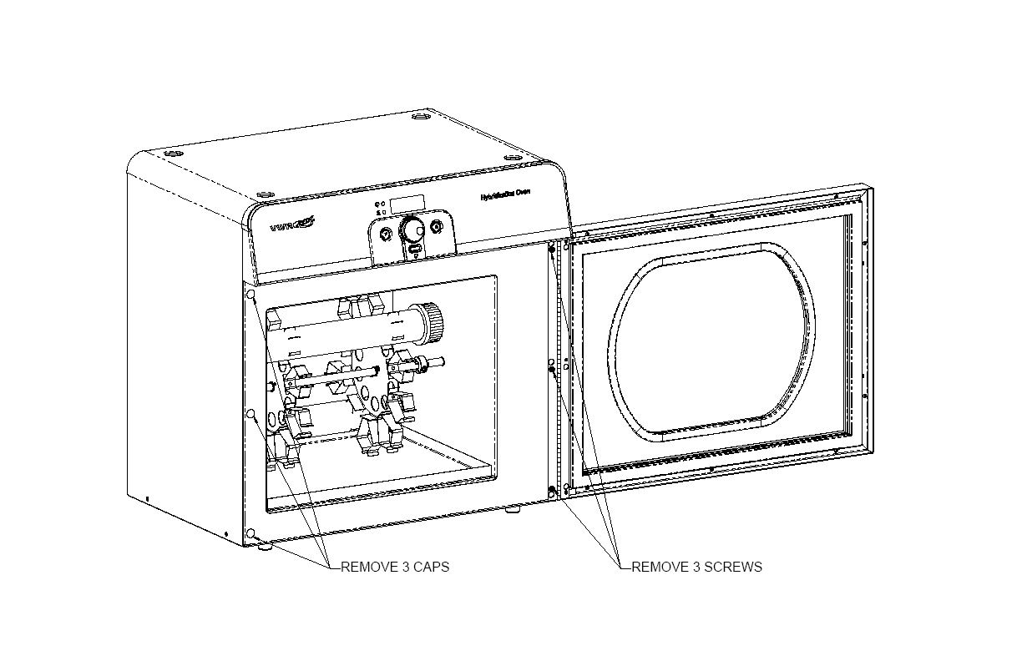Door Reversal:

`

Figure 3

8.1 The door on the hybridization oven is reversible for visibility. To change the doors position simply remove the 3 screws & 3 caps as show in figure 3. Using the same screws reposition the door to the side desired, be sure that all screws are secured properly. Place the caps in the unused holes that the hinge previously was mounted to.

9. Maintenance and Service
No routine maintenance is required.

9.1 Calibration

This product has been factory calibrated for optimum performance. A pedigreed individually serialized thermistor is used to monitor and control temperature in this unit. These thermistors are +/- 0.1° C absolute accurate, and +/- 0.01°C reproducible over time (for a given unit). The thermistor R-T table is stored digitally and is reproducible from unit to unit without the need of an individual calibration or re-calibration over item. Additionally, thermal modeling of the instrument allows for the inclusion of digital offsets to the R-T table in FLASH memory which eliminates the need for individual unit calibration. However, if a user has a specific need to recalibrate or add a temperature offset, please contact the “Boekel” customer service department at 1-800-336-6929, to request a copy of the calibration procedure.

9.2 Cleaning
Disengage power cord prior to cleaning. The floor of the chamber is protected with a removable stainless steel drip tray. If a spill occurs, use appropriate clean up procedures as required for radiation or biohazard control. The outer casing can be cleaned with a cloth dampened with water. Do not submerge or immerse the Hybridization Oven in water. The plastic on the front door must not be cleaned with any abrasive type cleaning agent. This will cause severe scratching of this material. Before using any cleaning or decontamination method except those recommended by the manufacturer, users should check with the manufacturer that the proposed method will not damage the equipment.

9.3 Replacement of Fuses
- Disconnect the unit from the power supply.
- Remove the plug from the socket in the back of the unit.
- Pull back on the fuse drawer catch.
- Pull out the fuse drawer (see Figure 4).
- Check and replace with the correct fuses if necessary.
- The fuses should be 5mm x 20mm:
230402 (115V) 4.0A/250v 3AG SLO-BLO
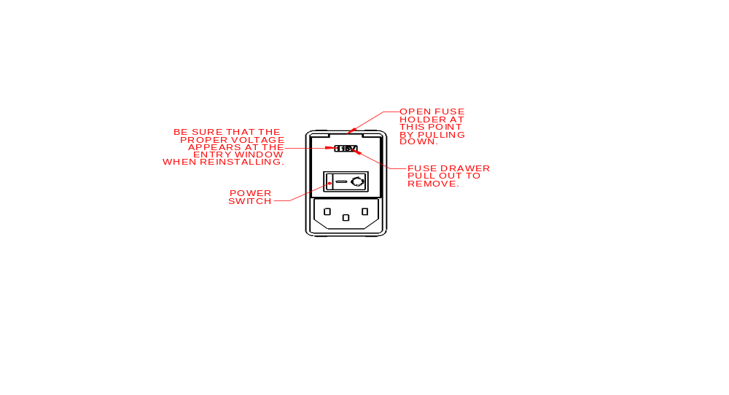 230402-2 (230V) 4.0A/250v 3AG SLO-BLO
- Push the fuse drawer back in. Reconnect unit to the power supply.

Figure 4

10. Warranty
When used in laboratory conditions and according to these operating instructions Boekel warrants this product to be free of defective material and workmanship for a period of two years from the date of manufacture. The liability of Boekel for any defective equipment during the warranty period shall be limited to the repair of such equipment or replacement thereof without charge for parts or labor.

11. Service
It is required to obtain a Returned Material Authorization (RMA) number before any Boekel products are returned for any reason. A Decontamination Certificate must be completed, signed by the user, and returned to Boekel Scientific prior to receiving the RMA number. Please be sure to mark the outside of the returned goods package with this RMA number to ensure prompt handling.

Boekel Scientific
855 Pennsylvania Blvd.
Feasterville, PA 19053
PHONE: (215) 396-8200 or (800) 336-6929
FAX: (215) 396-8264
e-mail: boekel-info@boekelsci.com

